Dear All

We are writing to request your sponsorship for the upcoming Bampton Beer Festival. The festival, which will be held on 5 August in St Mary’s Bampton, is a community-focused event that aims to celebrate local breweries and bring the community together. It also plays a key role in our outreach strategy and [Greenhouse](https://www.churchofengland.org/sites/default/files/2020-06/8pp%20Greenhouse%20Summary_Low%20Res.pdf) projects. The idea is that we return the church back to a community hub and not just a place for worship with the aim to welcome non-churchgoers across the threshold.

Last year was a huge success and we raised over £3k for our selected charities. [Mission Without Borders](https://www.linkedin.com/company/mission-without-borders-international/), [Special Effect](https://www.linkedin.com/company/specialeffect/) and the church itself (St Mary's Bampton).

**Mission Without Borders** is a Christian charity operating in Eastern Europe, doing a lot of work in Ukraine at present; that works in partnership with local churches in some of the poorest countries in the region. Their focus is on helping the most vulnerable children and families, in the most difficult places, to overcome poverty and experience the fullness of life. They help to provide welfare and support for those in need and believe that it takes a whole community to create happy and fulfilling childhoods.

[**Special Effect**](https://www.linkedin.com/company/specialeffect/)is a charity based in West Oxfordshire that's helping everyone with disabilities to enjoy video games for fun, inclusion, and rehabilitation. They know there's no one-size-fits-all way of doing this. That's why they’re not about sending out free games or video game equipment. In fact, they don't sell anything at all. They visit people to find out exactly what they want to play, and what they need to play it. Then lend them the equipment they need and support them until they can get the best out of it. By committing time, patience and expertise, Special Effects can open the door to self-esteem, confidence and a better quality of life.

As a non-profit event, The Bampton Beer Festival relies on the support of locals and businesses to make the festival a success. We are seeking to cover some of our fixed overheads in funding to help us cover the costs of organising the event, including, buying the beer and equipment, as well as marketing the festival.

[www.bamptonwithclanfield.org/bampton-beer-festival](http://www.bamptonwithclanfield.org/bampton-beer-festival)

In return for your sponsorship, we can offer you the following benefits:

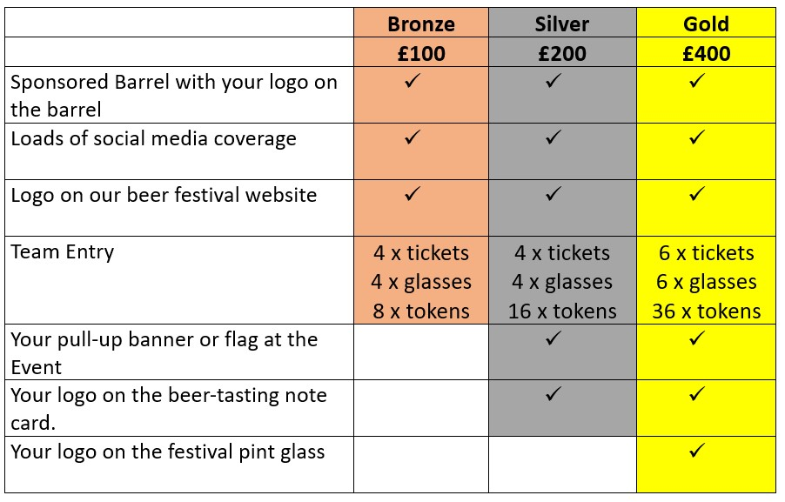

We believe that your company would benefit from sponsoring the Bampton Beer Festival as it would provide you with exposure to our target audience and align your brand with a worthwhile cause.

If you’re able to offer your valuable time and help us on the day; that would also be amazing support! We need help with setting up, tickets on the door, pulling pints, collecting glasses, and clearing up.

Please let us know if you are interested in sponsoring or volunteering at the Bampton Beer Festival or if you require any additional information. Please contact Pete at pete.john.saunders@outlook.com

We are happy to discuss the sponsorship package in more detail and answer any questions you may have.

Thank you for considering our request. We look forward to hearing from you soon.

Sincerely,

Pete Saunders

**Volunteer Event Organiser**